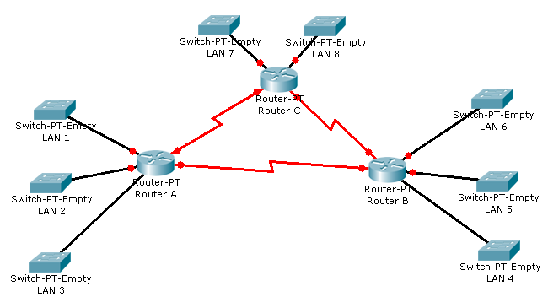

Number of Hosts:
LAN 1: 8000
LAN 2: 2000
LAN 3: 1000
LAN 4: 4000
LAN 5: 4000
LAN 6: 500
LAN 7: 254
LAN 8: 50

Base Address: 180.180.0.0/16

Procedure:

1. Which LAN has the most number of hosts- start with that LAN. In this case, it’s LAN 1.
8000 hosts require 13 bits in host portion. So, the prefix will be /19. So, we borrowed 3 bits from the base address- means there will be 8 subnets.
180.180.0.0/19 → Assign it to LAN 1
180.180.32.0/19
180.180.64.0/19
180.180.96.0/19
180.180.128.0/19
180.180.160.0/19
180.180.192.0/19
180.180.224.0/19

2. Which of the LANs have second most number of hosts- start with that LAN having the leftover subnet as the base address. In this case, it’s LAN 4, LAN 5. 4000 hosts require 12 bits in host portion. So, the prefix will be /20. So, we borrowed 1 bit from the base address- means there will be 2 subnets.
180.180.32.0/20→ Assign it to LAN 4
180.180.48.0/20 → Assign it to LAN 5
3. Which of the LANs have third most number of hosts- start with that LAN having the leftover subnet as the base address. In this case, it’s LAN 2.
2000 hosts require 11 bits in host portion. So, the prefix will be /28. So, we borrowed 1 bit from the base address- means there will be two subnets.
180.180.64.0/21→Assign it to LAN 2
180.180.72.0/21
4. Which of the LANs have fourth most number of hosts- start with that LAN having the leftover subnet as the base address. In this case, it’s LAN 3.
1000 hosts require 10 bits in host portion. So, the prefix will be /22. So, we borrowed 1 bit from the base address- means there will be two subnets.
180.180.72.0/22→ Assign it to LAN 3
180.180.76.0/22
5. Which of the LANs have fourth most number of hosts- start with that LAN having the leftover subnet as the base address. In this case, it’s LAN 6.
500 hosts require 9 bits in host portion. So, the prefix will be /23. So, we borrowed 1 bit from the base address- means there will be two subnets.
180.180.76.0/23→ Assign it to LAN 6
180.180.78.0/23
6. Which of the LANs have fourth most number of hosts- start with that LAN having the leftover subnet as the base address. In this case, it’s LAN 7.
254 hosts require 8 bits in host portion. So, the prefix will be /24. So, we borrowed 1 bit from the base address- means there will be two subnets.
180.180.78.0/24→ Assign it to LAN 7
180.180.79.0/24
7. Which of the LANs have fourth most number of hosts- start with that LAN having the leftover subnet as the base address. In this case, it’s LAN 8.
50 hosts require 6 bits in host portion. So, the prefix will be /26. So, we borrowed 2 bit from the base address- means there will be 4 subnets.
180.180.79.0/26→ Assign it to LAN 8
180.180.79.64/26
180.180.79.128/26
180.180.79.192/26

Now, we have completed subnetting the LANs. We will now subnet the address for serial links. There are 3 serial links each of them will require 2 hosts. Start with any of them with the base address of the leftover subnet. As we have borrowed 1 bit from the base address, there will be two subnets-
180.180.79.64/30→ Assign it to serial connection 1
180.180.79.68/30 → Assign it to serial connection 2
180.180.79.72/30 → Assign it to serial connection 3
180.180.79.76/30
180.180.79.80/30
180.180.79.84/30
180.180.79.88/30
180.180.79.92/30
180.180.79.96/30
180.180.79.100/30
180.180.79.104/30
180.180.79.108/30
180.180.79.112/30
180.180.79.116/30
180.180.79.120/30
180.180.79.124/30

